Curriculum Vitae
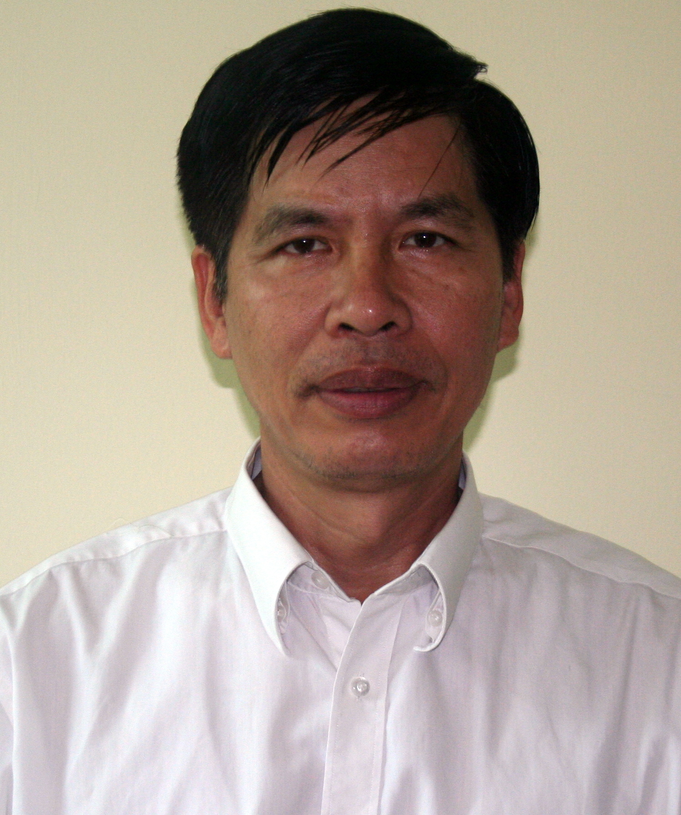

1. Name of Specialist: Pham Quoc Tuan

2. Name of Firm: Vietnam-German forestry Programme (GIZ/MARD)

3. Proposed Position: Component Manager/Specialist of FSC cirtification and GFA/ FSC Auditor

4. Date of Birth: 18 October 1956 Citizenship: Vietnamese

5. Address: CT-18 – Viet Hung City – Long Bien - Vietnam

6. Email: tuan.gtz@gmail.com ; Moby: (+24) 912567030

7. Summary of Professional Experiences

Mr. Pham Quoc Tuan is a Forester with over 20 years’ experience working with national and international organizations in trade, education, environmental and natural resource management, sustainable forest development/management and GFA/FSC National Auditor. Professional working experiences with GIZ; GFA; FAO; USAID and UNRED

8. Education:

- Master degree on Sustalable forest management from Forestry University of Vietnam, 2001;

- B.Sc. on forest planning and man

- agement from the Forestry University of Vietnam, 1979.

9. Key Qualifications:

- High quality managerial, interpersonal and team building skills with practical experience from projects and programs implementation
- Experience in the preparation of work plans, reporting and liaising with the most senior levels of government agencies
- Able to work under pressure and have extensive experience in a variety of field.

10.Membership of Professional Associations:

- Member of the Country Working Group on Sustaianble Watershed Management
- Member of Technical and Scientific Advisory Group for Implementation of National Forest Development Strategy
- Member of the National Community Forest Network from 2003.
- Member of country Working Group on FSC in Viet Nam from 2005
- Member of REDD+ Network in Vietnam from 2010
- Menber of SFEs Network in Vietnam suppoted by GIZ from 2012
- Menber of GFA-FSC National Auditor from 2010

7. Other Training:
- Ten months designing aerial photo mapping training course at FIPI, 1990;
- Five weeks training course on Community Forestry Development at RECOFTC in Karsetsart University, Bangkok, Thailand;
- PRA & RRA and Land use &land allocation for Rural development training course and practice in Sown La-Lai Chau at Social Forestry Development Project Song Da, Vietnam organized by GTZ, 1996;
- Administration and Planing Management/ Practice at MARD, 1997;
- TOT training course on Land use planing and Land allocation at SFDP Song Da; 1998; and 2000
- TOT training course on Village Development Plan at SFDP Song Da, 1999;
- UNEP/UNESCO International Short course on environmental management for developing Countries Conservation of Biodiversity/Ecosystem Management in Dresden – Germany, 2001;
- Improvement of the Training Quality in Colleges of Forestry and Agriculture at DSE-Center for Food, Rural Development, Zschortau – Germany, 2000;
- TOT training on community forest management in Thailand, 10/ 2002
- Sustainable forest management in Malaysia, 5/2006
- Assessment of forest management practices for Forest certification (FSC), London on 7/2007
- Climate Change ToT (SRD), Hanoi – 03/ 2009;
- Facilitation for Advanced Practioners (GIZ), Hanoi - August 2009;
- Media Training/ IUCN Vietnam, Ho Chi Minh City - November 2010;
- FSC certification standard Training United Kingdom , 2010;
- Facilitation and Moderation Training (GIZ), Hanoi - August 2010;
- Capacity WORKS Training (GIZ), Bangkok, April 2011;
- Advanced Communication Skills in Conflict Resolution (GIZ), Hanoi-11/ 2010;
- Management skill in Thai Land, October, 2011;
- CapaCity Work in Thailand, Mach, 2011;
- REDD+ training in Lam Dong , April, 2010
- REDD+ training in Quang Binh (GIZ/Vietnam) , May, 2012
- FSC Auditor training in Hanoi by GFA October, 2012
- Building SMEs International Competitiveness/MOIT, Hanoi-December 2013;

9. Professional experiences: over 20 years

1) FSC training support for Yen Son household group in Tuyen Quang province and Yen Binh household group in Yen Bai province to implement sustainable forest management activities and forest certification according to international standards from 2016-2017
2) Support Bao Yen forest company in Lao Cai province and Uong Bi forest Company in Quang Ninh province implementation FSC certification for Acasia forest plantation in 2016
3) Conduct assessment FSC feasibility study at state Forest Company Tuong Duong in Nghe An province in 2015 supported by USAID/VFD
4) Conduct assessment FSC feasibility study at State forest company Dak To in Kon Tum, Long Dai in Quang Binh provinces in 2012 supported by GIZ
5) Sustianble forest management planning and implementation FSC certification for natural forest and plantation for forest companies in MARD Viet Nam;
6) Identification and management of high conservation value forest (HCVF)
7) Harvesting design;
8) Reduced impact logging (RIL)
9) Forest road construction and maintenance;
10) EIA and SIA assesment
11) Land use and forest planning and allocation;
12) Village development planning of natural forest management;
13) Forest management inventory;
14) Forest co-management and benefit sharing (commune and villeges)
15) Training of Trainers (ToT) for forester officers on FSC standard at provincal, district and forest companies level;
16) Policy development for Forestry Sector;
17) Project/programme management/coordination;

10. Languages: Vietnamese and Good English

11. Employment Record:

From: September, 2017 to now freelancer

From: November, 2016 to August, 2017;

National Consultant for Assessment FSC feasibility study and training implementation at Bao Yen state forest company (SFC) in Lao Cai province supported by FAO/UN-RED+
- Support Bao yen SFC to developed sustainable forest management plan accordingly FSC standard and pre-auditor for FSC certification for Acacia plantation forest .
- Support Bao yen SFC to developed Business Management Plan (BMP) and SFCs requitization in VN and draw lesion from these documents and consult for technical working groups of FAO-PWC continuing to equalization process of Bao yen and FSCs.

From November, 2014 to October, 2015
National Consultant for Forest Management

Employer : FCPF-REDD+The Project “Support for the REDD+ Readiness Preparation in Vietnam” Positions: National Consultant for forest management and certification ( FSC).
- Review existing related policy and legal framework, and best domestic practices on smallholders forest management models, in particular in Hue, Quang Tri, Thai Nguyen, Dien Bien.
- Identify potential for replication of approaches developed (or under development) by FAO initiatives including EU-FAO-FLEGT; Forest and Farm Facility (FFF), FAO-IKEA partnership, FAO TCP on community forestry harvesting in BacKan, as intervention packages under PRAPs
- Review and assess on the key aspects on SFM potential in prioritized communes in Lao Cai, BacKan and Ha Tinh, including but not limited to followings:
- Support the design of the PRAP and roadmap for REDD+ implementation in the pilot provinces and support to implementation in pilot PRAP at THua Thien Hue province;
- Support for development of technical guidance, tools, training materials and organisation of training on sustainable management of forests for key staff of piloted SFCs and DARDs in collaboration with CTA and other project consultants;
- Support the REDD+ pilot model in FLA and SFMP to be implemented in Dak Nong, Quang Tri provinces
- Support Ben Hai SFC to developed Business Management Plan (BMP) and SFCs equitization in VN and draw lesion from these documents and consult for technical working groups of WB-PWC continuing to equitization process of Ben Hai and FSCs.
- Prepare a detailed capacity building proposal on forest related governance capacity, institutional establishment & techniques on sustainable management of forest of small-scale forest owners in the selected communes.
- Develop a strategic roadmap with specific measures to establish demonstration models for small-scale forest owners under UN-REDD Programme as specified in PRAPs of Lao Cai, BacKan and Ha Tinh for period 2016 – 2018. This roadmap should include stages/steps & key contents for small – scale SFM demonstration models, including policy recommendations and should use the intervention package template developed for use under the UN-REDD Viet Nam phase II programme

From: June, 2014 to October 2014

National Consultant for Assessment FSC feasibility study at Tuong Duong Forest Company in Nghe An province supported by USAID/VFD

To conduct assessment FSC feasibility study at state Forest Company Tuong Duong in Nghe An province in 2015 supported by USAID/VFD

From: October, 2009 to March, 2014

Employer: GIZ/Vietnammese-German Forestry Program

Positions: Head of Component Management on sustanable of Forest Management Plan and cirtification (FSC),

From: January 2005 to 2009
Employer: GIZ/Vietnamese-German Forestry Program
Positions held: Forestry Specialist

From: October 2003 to December 2005
Employer: GIZ/Vietnamese-German Technical Cooperation Program, Support to the Reform of the Forestry Administration System (REFAS)
Positions held: National Forestry Expert

From: April to Sept. 2004
Employer: WWF/Promotion of sustainable forest management project
Position held: Short term forestry advisor (case by case involvement)

From 11/2000- 8/2003
Employer: GTZ/Song Da Social Forestry Development Project (SFDP)
Position held: Regional coordinator/Technical Advisor

From: June 1998 to October 2000
Employer: GTZ/Song Da Social Forestry Development Project in Sơn la Province
Positions held: National project coordinator and advisor in Son La – Lai Chau provinces

From: May 1995 to June 1998
Employer: GTZ/Song Da Social Forestry Development Project - FiPi

Position held: Project coordinator and National forestry advisor,

From: 01 January 1991 to May 1995
Employer: Forest Inventory and Planning Sub-Institute in the Northwest, located in Hanoi
Positions held: Vice head of Technical Section of Forest Inventory and Planning Institute (FIPI) in Hanoi

From: December 1982 – December 1990
Employer: Forest Inventory and Planning Sub-Institute in the South of Central Region and Central highlands, located in Dak lak (Sub-FIPI)
Positions held: Vice Director of sub-FIPI in Dak Lak

From: 01 August 1979 – December 1982
Employer: Forest Inventory and Planning Sub-Institute in South of Central Region and Central Highlands located in Quy Nhon City (Sub-FIPI);
Positions held: Forest officer

13. Detailed Tasks Assigned
Name of assignment or project: Forest inventory and forest development planning in Dak Lak and Gia Lai provinces

Year: 1979 -1990
Location: Dak Lak and Gia Lai provinces
Client: Forest Inventory and Planning Institute (FIPI)
Main project features: carry out forest resources inventory to have inputs for elaboration of the provincial forest development plan in Dak Lak and Gia Lai
Positions held: Forestry Planner
Activities performed:
- Provided TOT training on forest development planning to provincial forest planners;
- Developed short - medium and long-term provincial forest development plans in collaboration with other line agencies in the provinces;
Name of assignment or project: Forest Inventory and Planning Institute (FIPI)
Year: 1991- 1995
Location: Hanoi
Client: Ministry of Forestry
Main project features: FIPI is responsible for forest inventory in the whole country. The Institute is asked by the Government to carry out national forest resources inventory every 5 years. Results of the national inventory is published and officially used by all levels for development of the national/provincial/district/commune forest development plan.
Positions held: Forestry Planner
Activities performed:
- Designed forest planning method/tools
- Developed forest management plan for corporations and state forest enterprises as required;
- Elaborated provincial forest development plans for provinces as requested;
- Provided consultancy and assisted provinces in elaborating forest development plans;
- Carried out training needs assessment on forest planning at various levels in Vietnam and Laos;
- Developed training program and delivered training on forest planning for forestry technicians in Vietnam and Laos;

Name of assignment or project: GFA-Song Da Social Forestry Development Project
Year: 1996-2002
Location: Hanoi, Son La and Lai Chau provinces
Client: Ministry of Agriculture and Rural Development (MARD)

Main project features: The Song Da SFDP was implemented from 1993 to 2004 by German Technical Cooperation Agency (GFA) and Department of Forestry of Vietnam. The project was aimed to improve socio-economic situation of local inhabitants in Son La and Lai Chau provinces by introducing and applying sustainable farming systems. One of the main activities of the project was to assist and strengthen the capacity of the provinces in developing forest development plan.
Positions held: National Project Coordinator and Technical Advisor
Activities performed:

- Introduced participatory planning approach and relevant planning tools;
- Elaborated the provincial/district/commune forest development plan for two pilot provinces;
- Supervised and designed participatory land use planning and commune/community forest development (CDP/VDP) of two pilot provinces;
- Developed models on Forest land use planning and land allocation in Thai, H’Mong Ethnic minority and commune level.
- Provided training on land use planning, land allocation and commune development planning;
- Established upland agro-forest farming system and assisted in plantation development;
- Provided training on silvicultural management practices applied for different forest status and plantation periods;
- Responsible for managing and supervising all forestry-related activities of the project;
- Assisted in developing forest land use planning and carrying out forest land allocation process;
- Provided training on forest inventory, land use planning, land allocation and commune development planning to the project staff and provincial agencies;
- Developed agro-forestry production models;
- Community forest management and forest extension
- Established upland agro-forest farming system and assisted in plantation development through introduction of appropriate silvicultural management techniques and site-matching species;
- Provided training on silvicultural management practices applied for different forest status and plantation periods;
- Monitored performance of the established models and provided necessary technical guidance for improvement;

Name of assignment or project: Vietnamese-German Technical Cooperation Program, Support to the Reform of the Forestry Administration System (REFAS)
Year: 2003-2005
Location: Hanoi, Thanh Hoa, Dak Nong, Son La and Dak Lak provinces
Client: GTZ
Main project features: This project aimed to assist MARD in establishing an administrative system in the forestry sector through provision of demands oriented services under an appropriate forest management know-how and policy framework.
Positions held: National Forestry Advisor
Activities performed:
- Coordinated and monitored the project activities at national and local level;
- Provided guidance and advice to designing the Provincial Forest Strategies (PFS) in accordance with the national guidelines;
- Advised to develop district and commune development plans (DFP, CFP) in pilot districts and communes of the selected provinces;
- Disseminated piloting experiences on PFS, DFP, CFP development to other provinces as Gia Lai, Kon Tum, Lam Dong, Quang Nam, etc.;
- Advised and assisted 2 SFE in Dak Lak and Dak Nong, in developing forest management plan in accordance with FSC requirements;
- Coordinated and followed up project activities supporting the development and implementation of provincial Forest strategy at pilot provinces;
- Provided technical support and guided district and commune working group to develop district and commune development plan;
- Designed planning guidelines/tools for commune and village levels;
- Developed training plan and delivered training on forest development planning at province, district and commune level.
- Guided development and implementation of commune/village development plan (VDP, CDP) under an additional poverty alleviation program (AP 2015) in Thanh Hoa and Dak Lak provinces.
- Monitored and evaluated VDP, CDP implementation for experiences dissemination and scaling up
- Established 2 plantation demonstration plots (10 ha each) on these 2 SFE area taking into consideration of the findings from the conducted comprehensive inter-disciplinary analysis, field survey and market orientation while meeting the set socio-economic and environmental objective.
- Regularly monitored and followed up the implementation of the experimental plantation models and worked out on-time management solutions;
- Advised and provided assistance to species selection and forest management techniques (soil preparation, plantation, tending, etc.) for the implementation of the commune/village development plan (VDP/CDP) under the AP 2015 programme
- Established agro-forestry production models in selected poor communes of the AP2015 programme.
- Be responsible for monitoring and evaluation of the entire project at both national and pilot province.

Name of assignment or project: Vietnamese-German Forestry Programme (GTZ/FP)
Year: 2005 -2009
Location: Hanoi, Dak Lak, Kon Tum, Quang Binh, Ninh Thuan, Yen Bai
Client: GTZ
Main project features: This project promotes sustainable utilization and management of natural forests and marketing of important forest products. Development of a synchronous forest planning system at all levels is the project focal point, including elaboration of SFE’s forest management plan in accordance with FSC requirements.
Positions held: Forestry Specialist/Component Manager.
Activities performed:
- Advised Ministry of Agriculture and Rural development (MARD) to develop Circular guiding elaboration of forest protection and development plans at province, district and commune level;
- Advised and guided Quang Binh province (national pilot case) to develop forest protection and development plan at 3 levels in accordance with the draft circular for lesson learnt and improvement before application on the whole country;
- Assisted Dak Lak, Kon Tum, Ninh Thuan and Yen Bai provinces in collecting information, surveying forest resources to have inputs for development of the provincial forest protection and development plan;
- Supervised and assisted in designing sustainable forest management plan of 5 selected SFEs as sample for certification;
- Developed technical guidelines on elaboration of forest land use planning and land allocation and red book cirtification for SFEs;
- Developed technical guidelines on elaboration of forest management plan for SFEs;

Name of assignment or project: Vietnamese – German Forestry Program (GIZ/MARD)
Year: 2009 up to March 2014

Location: Quang Binh, Dak Lak , Gia Lai, Yen Bai and Ninh Thuan provinces
Client: Vietnamese – German Forestry Program

Main project features: This project promotes sustainable utilization and management of natural forests and marketing of important forest products. Development of a synchronous forest planning system at all levels is the project focal point, including elaboration of SFE’s forest management plan in accordance with FSC requirements
Positions held: Forestry specialist and Component Management on sustanable Forest Management plan (FSC)
Activities performed:
- Supervised and assisted in designing sustainable forest management plan of 5 SFEs;
- Carried out thematic surveys and studies at national and local levels (socio-economic impacts, flora/fauna and bio-diversity, forest policy impacts, etc.).
- Designed technical guidelines and natural forest inventory schemes;
- Developed instrument and guidelines on forest function mapping and zoning for accurate inventory;
- Provided training courses on forest inventory, volume calculation (using VIDARD software) for staff of provincial Department of Forestry and SFEs;
- Participated in forest inventory and survey in SFEs
- Developed technical guidelines on silviculture management
- Developed technical guidelines on forest management plan in SFEs;
- Suport Dak To and Truong Son SFEs implementation of activities on timber harvesting according FSC cirtification reqiurment.
- Coordinated with WWF, World Bank, and EU projects to facilitate integration of best practices into national policy forums.
- Managed operations in the field of forestry SFMP.
- Managed the activities including the budget allocations with regards to forestry in accordance with GIZ guidelines and principles.
- Supported the development of technical guidance, tools, and training materials as well as training on sustainable forest management for piloted SFCs and DARD
- Review existing related policy development and legal framework on sustainable forest management, and best domestic practices on smallholders forest management models,
- Prepare a detailed capacity building proposal on forest related governance capacity, institutional establishment & techniques on sustainable management of forest of small-scale forest owners in the selected communes.
- Develop a strategic roadmap with specific measures to establish demonstration models for small-scale forest owners under UN-REDD Programme as specified in PRAPs of Lao Cai, BacKan and Ha Tinh for period 2016 – 2020. This roadmap should include stages/steps & key contents for small – scale SFM demonstration models, including policy recommendations and should use the intervention package template developed for use under the UN-REDD Viet Nam phase II programme

13. Referees

Name | Title | Organisation | Email | Phone
Dr. Christopher Turtle | FCPF-REDD+ | CTA | christopher_turtle@yahoo.com | T +84 43728 6459  F +84 43728 6496
Dr. Juergen Hess | GIZ/MARD | Program Director of GIZ/MARD | E juergen.hess@giz.de  I www.giz.de/vietnam | T +84 4 393 29 572  F +84 4 393 29 575
Mr. Nguyen Ba Ngai | Vice Chaiman | Vietnam administration of Forest | nguyenbangai@gmail.com | 091 206 2179
Mr. Vo Dai Hai | Derector | Vietnammese Academy of Forest Sciences | info@vafs.gov.vn  haivodai@gmail.com | 098 300 4638  84.4.38389721

Date: 20/10/2017


Pham Quoc Tuan

